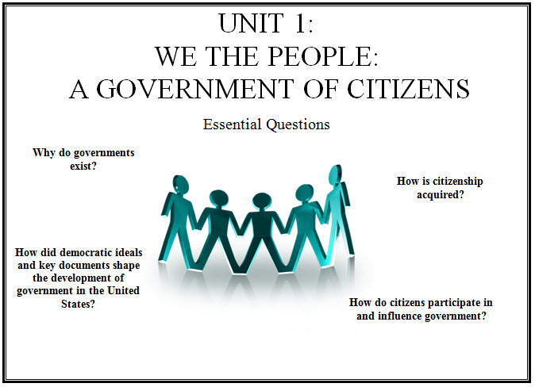

8.1.1 Explain the basic purposes of government. (CE.13b) Pg 45-46
- provide public goods and services* protect citizens
- keep order
8.1.2 Examine influences on the development of democratic ideals.
- Athenian democracy – rule of the people
- Magna Carta – rule of law, limited government P. 92
- English Bill of Rights –individual rights pg 93
- Mayflower Compact—population sovereignty, self rule P. 83
- John Locke- life, liberty, property p. 93-94
8.1.3 Describe fundamental principles of democratic government. (CE.2a, .2b)
- protection of fundamental freedoms* Pg 163-165
- consent of the governed* p. 92 (see Republic)
- limited government* P.129-131
- representative government* p. 92
- majority rule with protection of minority rights*
- rule of law* p.61
- popular sovereignty
8.1.4 Explain the significance and relevance of key documents that influenced the Constitution of the United States of America. (CE.2b) P. VA 705-707
- Charters of the Virginia Company of London* P. V-2
- The Virginia Declaration of Rights* p. V10
- The Virginia Statute for Religious Freedom* P. V11
- The Declaration of Independence* P/ 97-98
- Articles of Confederation—first form of government for the United States* P. 99-100
8.1.5 Describe the sources of citizenship. (CE.3a) pg. 56-57
- birth*
- naturalization*
- Fourteenth Amendment—defines citizenship*

8.1.6 Describe the naturalization process. (CE.3a) p. 56-57
- ability to read, write, and speak English in ordinary usage*
- knowledge of American history and principles*
- residency
- oath of allegiance
8.1.7 Describe the duties of citizenship. (CE.3c) p. 59-64
- obeying laws*
- paying taxes*
- serving in the armed forces if called*
- serving on a jury*
- serving as a witness in court*
8.1.8 Identify the responsibilities of citizens. (CE.3d) p. 65-67
- registering to vote*
- holding elective office*
- influencing government by communicating with government officials*
- serving in voluntary appointed positions*
- participating in political campaigns*
- keeping informed regarding current issues*
- respecting rights of others to have an equal voice in government*
8.1.9 Explain the difference between the duties and responbilities of citizenship. (CE.3c, 3d) p. 60-65
- duties—required*
- legal consequences if duties are not performed*
- responsibilities—voluntary*
8.1.10 Identify personal character traits of good citizens. (CE.4a, .4b, .4c, .4d, .4e, .4f, .4g)
- trustworthiness and honesty*
- courtesy and respect for the rights of others*
- responsibility, accountability, and self-reliance*
- respect for the law*
- patriotism*
- participant in the school and/or local community*
- informed voter*
8.1.11 Identify ways citizens participate in community service. (CE.3e, CE.4g) p. 74
- volunteering for organizations, (e.g., the League of Women Voters)*
- volunteering for public service organizations*
- tutoring*
- expressing concern about public issues*
8.1.12 Identify skills involved in effective participation in civic life. (CE. 4g)
- formulating questions*
- analyzing information*
- expressing a position*
- devising and implementing a plan*

