Car Wash
Friday
9:00 to 5:00
Kids F.A.C.E.
Mission Statement
The mission of Kids for A Clean Environment is to provide information on environmental issues to children, to encourage and facilitate youth’s involvement with effective environmental action and to recognize those efforts which result in the improvement of nature.
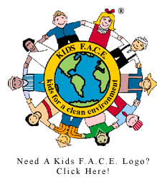

*All proceeds go to the highway trash cleanup

Interest Group Project

Create a flyer or pamphlet for an Interest Group

Poster/project must include:
____ Name of interest group (5 points)

____ Logo or design illustrating goals of group (10 points)

____ A mission statement of 30 words or more (10 points)

____ An event to raise awareness of issue (5 points)

____ A specific goal for your organization (10 points)

____ Total

** Please follow instructions. See example for mission statement writing.
Due on: __________________________________________________

