CITIZEN SERVICE OPPORTUNITY
Engage
Whole class viewing of Video
After viewing the video and examining our learning target which is:
I can design a service opportunity in my school, community and/or country to demonstrate my participation in civic life.
What do you think you are going to have the opportunity and privilege to do?
Think/Pair/Share with a shoulder partner and record your responses below. Be ready to share.
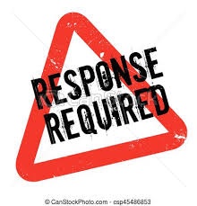

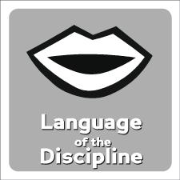 | Explore Sustainability
 | View the following Video. Collaborate with a partner and construct a definition of Sustainability. Please enter it below:
Partner up and distinguish between the three types of sustainability by categorizing each of the following videos in the chart below. What rules define each type?

Video | Economic | Social | Environmental
Food
Glaciers
Money
**Does each fit in only one category? If not, why not? Why do they converge? What relationships exist between them? Discuss

Explain why?
Why volunteer? And what skills do you need to volunteer?
Choose two of the following links to read and discuss with your partner. In the space below, identify why you should volunteer. Cite evidence to support your opinion.
Everyone benefits 5 Reasons Skills

Apply
THIS IS IT!

Share
View a student product. Discuss what you observe

Reflect
Complete the following Exit Ticket
Examine the following quotes about service

1. Service to others is the rent you pay for your room here on earth. Muhammad Ali

2. The best way to find yourself is to lose yourself in the service of others. Mahatma Gandhi

3. To give real service you must add something which cannot be bought or measured with money, and that is sincerity and integrity. Douglas Adams

4. Without community service, we would not have a strong quality of life. It's important to the person who serves as well as the recipient. It's the way in which we ourselves grow and develop. Dorothy Height

5. Do what you can to show you care about other people, and you will make our world a better place. Rosalynn Carter

Which quote resonates most with you and why?

Create a quote of your own for which you’d like to be remembered.

Extend
Check out these links for more wonderful Citizen Service ideas:
40 Ways 50 Ideas Hurricane Florence relief
More Community Ideas 5 Meaningful Ideas
Red Cross Youth and more

