Name: ______________________ Date: ______ Block: _____ Page: ______
Checks and Balances
Directions: Listed below are specific checks by which one branch of government can exert some control over another branch. Write who is applying the check on who in the space provided. Use “E” for executive, “J” for judicial, and “L” for legislative. For example, J > L (Judicial over legislative).

________1. Impeach judge from office

________2. Veto laws

________3. Appoint judge

________4. Override veto

________5. Call special sessions of Congress

________6. Declare a law unconstitutional

________7. Grant a reprieve

________8. Approve appointments

________9. Ratify treaties

________10. Declare Presidential acts unconstitutional

________11. Impeach President

________12. Confirm or deny ambassadors

________13. Confirm or deny Supreme Court Justices

________14. Judicial Review

________15. Prepare annual budget ($)
Checks and Balances
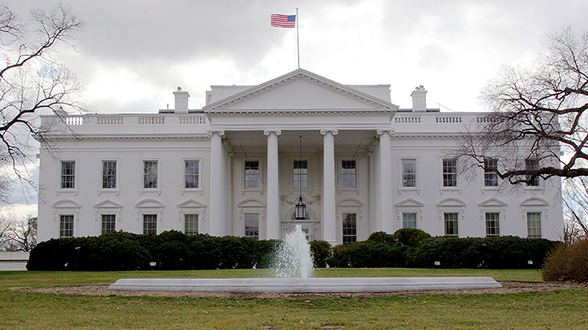
EXECUITIVE
BRANCH
(President)

6

2

NATIONAL
GOVERMENT

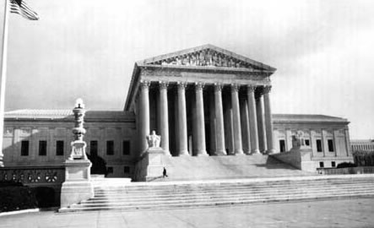

JUDICIAL
BRANCH
(Supreme Court)
CHECKS AND BALANCES

5
4
3
1
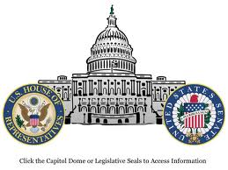
LEGISLATIVE
BRANCH
(Congress)

